LESSON 7.

Classification, morphology and ultrastructure of protozoa

LESSON PLAN:
- Structural features of eukaryotic cells.
- Classification of parasites: Protozoa.
- Morphology, ultrastructure of protozoas.
- Pathogenic protozoas of Sarcomastigophora, Apicomplexa, Ciliophora and Microspora types.
- The examination methods of protozoas morphology.
- Giemsa stain techniques and the mechanism of its differential staining.

Protozoa - (protos-first, zoon-animal) are single-celled eukaryotic microorganisms. Sizes may be range from a few microns to 100 microns. They have a formed and separated from the cytoplasm by a special membrane nucleus and nucleoli, have cytoplasm with organelles inside and the outer membrane - the pellicle.
- Some protozoa move with pseudo legs - pseudopods, some with flagella and others with lashes. In some protozoa without motion organelles, motion is provided by microtubules. Cytoplasm of protozoa contain folding and unfolding vacuoles that perform a secretory function. Protozoa reproduce asexually and sexually. Some pathogenic protozoa undergo a complex developmental cycle by changing primary and intermediate hosts. Under unfavorable conditions, some protozoa form cysts that are resistant to the environment.
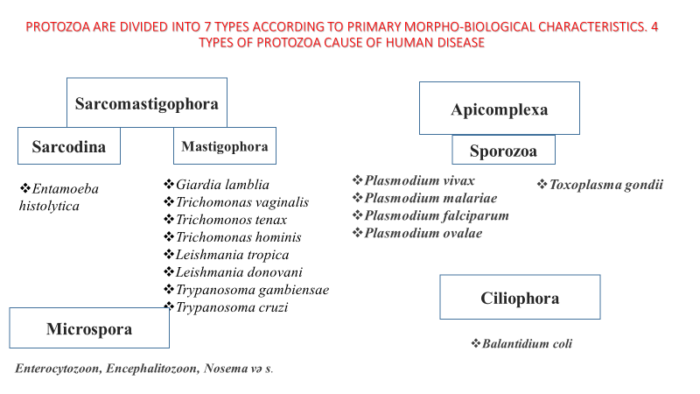

It is divided into Sarcodina and Mastigophora subtypes.
- Protozoa of the Sarcodina subtype are variable in body structure and form pseudopods. The pathogen Entamoeba histolytica is the causative agent of amoebic dysentery.
- Protozoa of the Mastigophora subtype are characterized by the presence of flagella. These group includes the causative agents of leishmaniasis - Leishmania, the causative agents of giardiasis - Giardia, the causative agents of trichomoniasis – Trichomonas, etc.
Apicomplexa type
- The presence of an apical (terminal, end) complex is characteristic.
- This complex allows the parasite to enter the host cell.
- They are intracellular parasites.
- It undergoes a complex development cycle with changing primary and intermediate owners.
- At each stage, the shape and characteristics of parasites change.
- Pathogenic representatives include malaria plasmodium, toxoplasma, etc.
- It is characteristic to have an apical (terminal, end) complex. This complex allows the parasite to enter the host cell
- They are intracellular parasites
- Primary and intermediate hosts go through a complex development cycle by changing.
- At each stage, the form and characteristics of the parasites change
- Pathogens include Plasmodium malaria, Toxoplasma, etc
Ciliophora type
- Species of this type are motile, have lashes that cover the entire body surface
- The pathogen Balantidium coli causes balantidiosis, which is accompanied by damage to the large intestine
Microspora type
- Species of this type - microsporidia are obligate intracellular parasites.
- They cause opportunistic infections in people with weakened immune systems (in immunocompromised patients)
- These parasites reproduce by forming special spores - sporoplasm
STUDING METHODS THE MORPHOLOGY OF PROTOZOA
- The morphology of the protozoa is studied in the native and stained preparations
- In this preparation, the nucleus of the parasite is red and the cytoplasm is blue-purple)
- The morphology of the protoza can be studied in the native case (in the prepressed "crushed drop").
- The prepared native drug is first examined with a small microscope lens (x10) and then with a relatively large (x40) dry lens. Movable vegetative forms of parasites can be detected even when examined with a small microscope lens. However, the drug must be examined with a large lens to determine whether it is a parasite.
- Under the microscope, it is possible to immediately determine the type of parasite (sarcodins, mastigophores, ciliates). In addition, due to the nature of their movement, it is sometimes possible to distinguish the forms of parasites within a species. For example, the progressive impulse to move between vegetative forms of amoebic dysentery is characteristic only of the large vegetative form (tissue form).
- In native preparations, cysts of parasites have a stable form, in contrast to the vegetative forms.
- However, it is not possible to observe the structure of cysts of parasites in native drugs, for example, their nuclei are very difficult to distinguish. However, in cysts of amoebic dysentery, chromatid bodies in the form of bright patches or clumps can be well observed.
- Therefore, in order to differentiate, preparations stained with Lugol's solution are used.
- Ingredients of Lugol's solution: potassium iodide - 3 g, crystalline iodine - 1.5 g, distilled water - 100 ml. Potassium iodide is first dissolved in distilled water, and then crystalline iodine.
- Cysts of parasites are stained golden-brown in preparations stained with Lugol's solution.
- It should be noted that vegetative forms of parasites are difficult to detect in preparations stained with Lugol's solution, as they are destroyed.

